***EDUCATIONAL ORGANIZATIONUSING SERVICE NOW***

**TEAMID - NM2025TMID17232**

**GROUP LEADER: M.SOMASUNTHARAM**

**GROUPMEMBERS:**

* **1. SARAVANAN.S**
* **2. SARAN.A**
* **3. PRIYADHARSHAN.S**

## SUBTITLES

* + **Introduction**
  + **SettingupServicenowInstance**
  + **Createaupdateset**
  + **Createatable**
  + **FormLayout**
  + **FormDesign**
  + **NumberMaintenance**
  + **ProcessFlow**
  + **ClientScript**
  + **Conclusion**

INTRODUCTION

**A leading institution dedicated to empowering students and faculty through innovative learning experiences.LeveragingServiceNow'scutting-edge technology, we've streamlined our operations to enhance student engagement, faculty support, and administrative efficiency. Our platform enables seamless management of student services,incident resolution, and knowledge sharing, fostering a collaborative and productive environment.**

## SETTINGUPSERVICENOWINSTANCE

* **SettingUpServicenowInstance**
* **signingupontheServiceNowDevelopersite requesting**
* **Apersoninstance,fillingdetailsandreceivinglogin credentials via email.**
* **Onceloggedin,userscanaccessandnavigate Service Now for further project development**

# CREATINGAUPDATESET

**Step1: Login to your Service Now instance.NavigatetoSystemUpdateSets Step2: ClickNew**

**Step3:EnteraNameforyourupdateset( “Welcome to Service Now Update Set").**

**Step4:EnteraDescriptionforyourupdateset Step5: Click Submit**

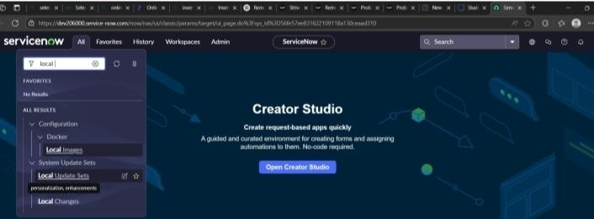

# CREATEATABLE

1. **CREATINGSALESFORCETABLE**

Step 1- All>>Tables Step2-Clickonnew

Step3-EntertheLabel(Anythingyouwant)Salesforce>> Click on Name it willAutomatically generateApiname.

Step4-DoubleClickonColumnlabeland Enter the Column labels and click on the tickmark>>GiveTypeas given

**Step5-For“AdminNumber”GiveDisplayasTrue and right click on the toggle bar on top>>save Step 6- Click on controls>>Enable Extensible Step7-ClickonAdminNumbercolumn,InRelated Links ClickonAdvanced View>> Default View (Enable Use dmynamic default)>> select Padded Number in Dynamic default value >>Update**

**Step8- Clickon“ Grade” Column>>Clickon Choices and give Label,Value**

**andSequenceasgivenbelow**

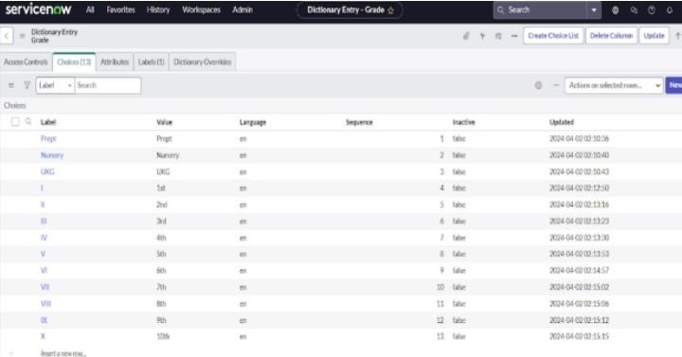

# CREATEADMISSIONTABLE

**Step1-CreateanAdmissionTablewith Columns given.**

**Step2-SelectExtendsTable>>Salesforce and also Select Add module to menu>>Sales force**

**Step3-CreateFieldsasshown**

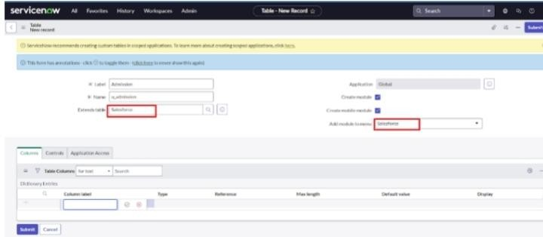

**Step 5- Crea techoice for pincode Step6-CreatechoiceforPurposeof Join**

**Step7-CreatechoiceforSchool**

**Step8-CreatechoiceforSchoolArea**

# FORMLAYOUT

**ConfiguringTableformforStudentprogress Table**

Step1-IntheStudentProgresstablePage,ClickonLayout form.

Step2-ClickonAdmissionNumber[+]

Step3-SelectbelowAdmissionNumberfieldsinAvailable side and send it

toselectedsideasbelow>>save.

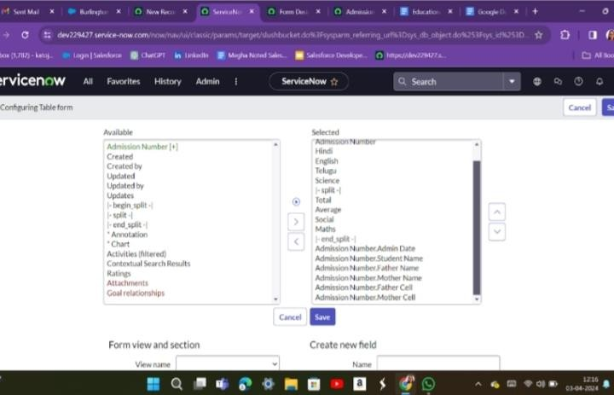

# FORMDESIGN

1. **CreatingFormDesignforSalesforceTable**

Step1-All>>SystemDefinition>>Tables.

Step2-InLabelSearchforSalesforceandopen.

Step3-RightClickontopToggle>>Configure>>Form Design.

Step 4- In drop down select Sales force(u_salesforce). Step5-Draganddropthefeldstotheleftsideasbelow

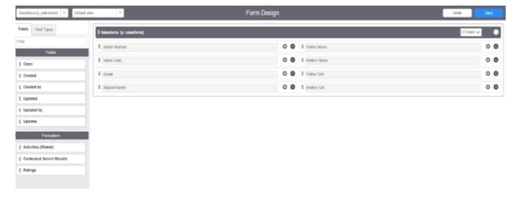

## CreatingFormDesignforAdmissionTable

**Follow the same step asActivity1 , Configure the field sa below and Save.**

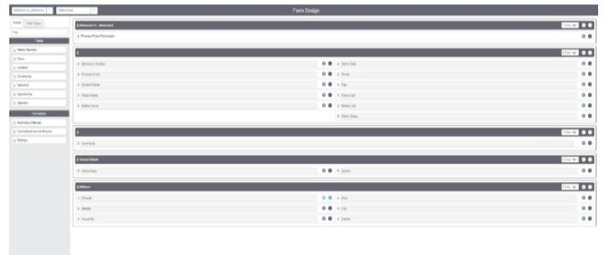

1. **CreateFormDesignforStudprogressTable**

FollowthesamestepasActivity1,Configurethefieldsas below and Save.

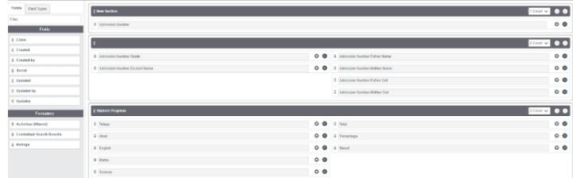

# NUMBERMAINTENANCE

Step1-All>>NumberMaintenance>>New Step 2- Fill the details>>Submit.

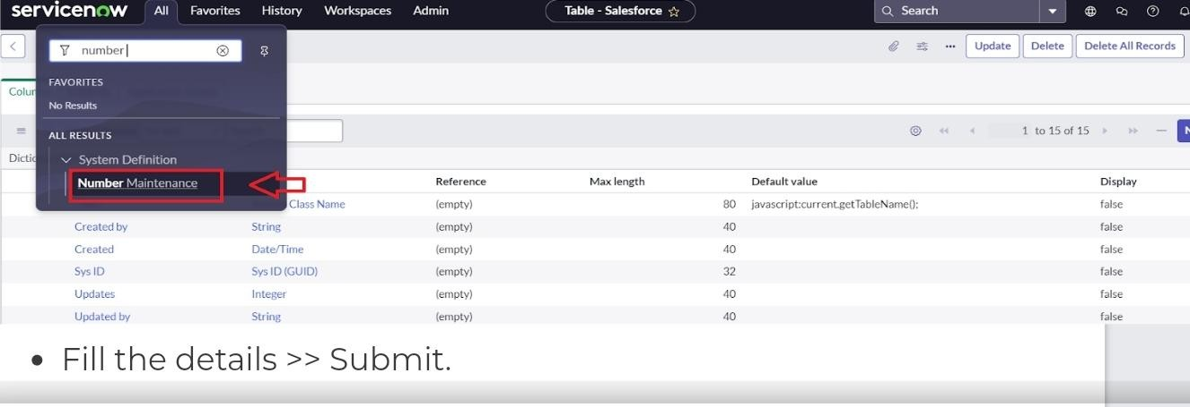

# PROCESSFLOW

Step1-All>>ProcessFlow>>New. Fill the Details as given Below

Step2-RightClickontoggleandclickonthesave.

Step3-ReplacetheNameandLabelasbelowandclickon Insert on stay.

Step4-ReplacetheNameandLabelinorderandclickon Insert on stay.

Step5-Joined>>Rejected>>Rejoined>>Closed>>Cancelled.

Step6-OrdershouldbeNew>>InProgress>>Joined>> Rejected >>Rejoined >> Closed >> Cancelled.

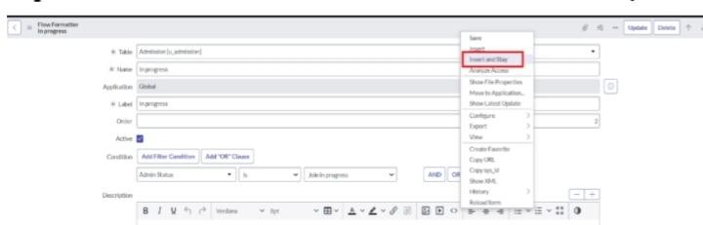

## CLIENTSCRIPT

1. **Creating“Autopopulate”ClientScriptsfor Admission Table**

**Step1-All>>ClientScripts>>New. Step 2- Fill the Details as given.**

**Step3-WritetheCodeasbelow,EnableIsolatescriptandSave. function onChange(control, oldValue, newValue, isLoading, isTemplate)**

**{**

**if(isLoading||newValue===''){ return;**

**}**

//Type appropriate comment here, and begin script below var a = g_form.getReference('u_admission_number'); g_form.setValue('u_admin_date',a.u_admin_date); g_form.setValue('u_grade',a.u_grade); g_form.setValue('u_student_name',a.u_student_name); g_form.setValue('u_father_name',a.u_father_name); g_form.setValue('u_mother_name',a.u_mother_name); g_form.setValue('u_father_cell',a.u_father_cell); g_form.setValue('u_mother_cell',a.u_mother_cell); g_form.setDisabled('u_admin_date',a.u_admin_date);

g_form.setDisabled('u_grade',a.u_grade);

g_form.setDisabled('u_student_name',a.u_student_name); g_form.setDisabled('u_father_name',a.u_father_name);

g_form.setDisabled('u_mother_name',a.u_mother_name); g_form.setDisabled('u_father_cell',a.u_father_cell);

g_form.setDisabled('u_mother_cell',a.u_mother_cell);

}

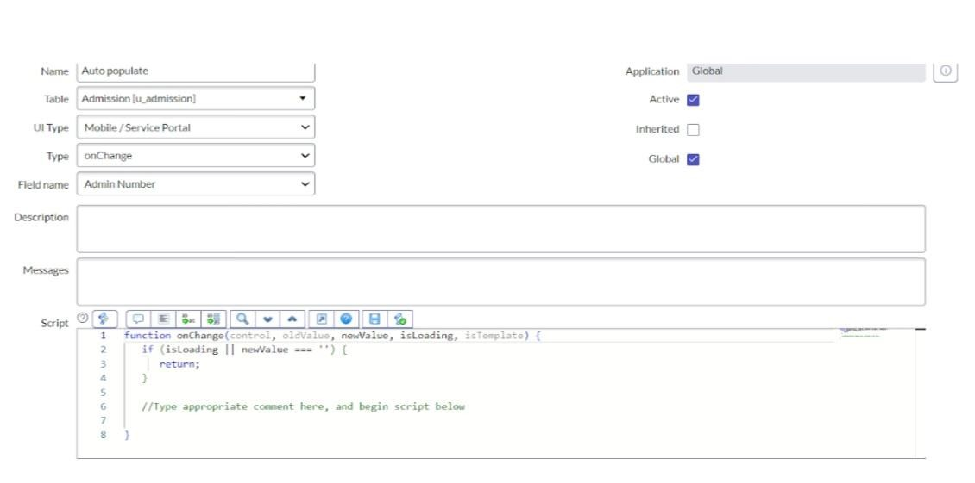

FilltheDetailsas given

1. **Creating“PincodeUpdate”Client**

**ScriptsforAdmissionTable**

Step1-FilltheDetailsasgiven

Step2-WritetheCodeasbelow,EnableIsolatescript and Save.

functiononChange(control,oldValue,newValue, isLoading, isTemplate) {

if(isLoading||newValue===''){ Return;

**}**

vara=g_form.getValue('u_pincode'); if(a == '509358')

{

g_form.setValue('u_mandal', 'kadthal'); g_form.setValue('u_city', 'kadthal'); g_form.setValue('u_district','RangaReddy');

}

elseif(a=='500081')

{

g_form.setValue('u_mandal', 'karmanghat'); g_form.setValue('u_city', 'karmanghat'); g_form.setValue('u_district','RangaReddy');

**{**

**elseif(a=='500079')**

**{**

**g_form.setValue('u_mandal', 'Abids'); g_form.setValue('u_city', 'AsifNagar'); g_form.setValue('u_district', 'Hyderabad');**

**}**

**//Typeappropriatecommenthere,andbegin script below**

**}**

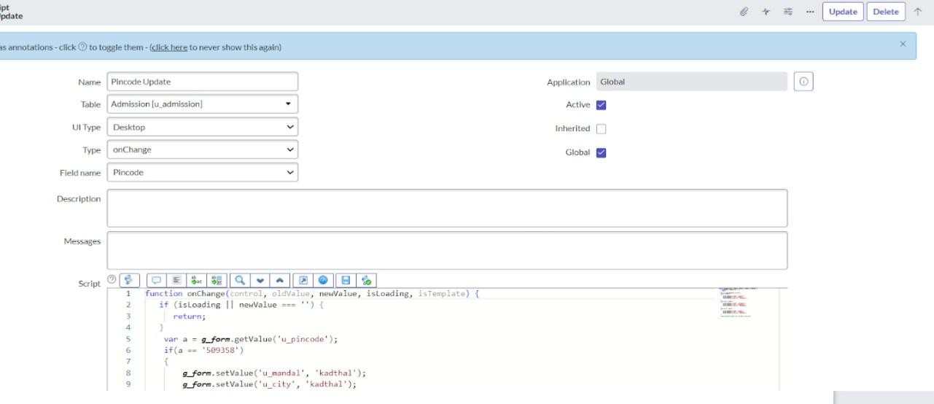

1. **Creating“DisableFields”ClientScriptsfor Student progress Table**

Step1-FilltheDetailsasgiven.

Step2-WritetheCodeasbelow,EnableIsolatescript and Save.

functiononLoad(){

//Typeappropriatecommenthere,andbeginscriptbelow g_form.setDisabled('u_total',true); g_form.setDisabled('u_percentage',true); g_form.setDisabled('u_result',true);

**}**

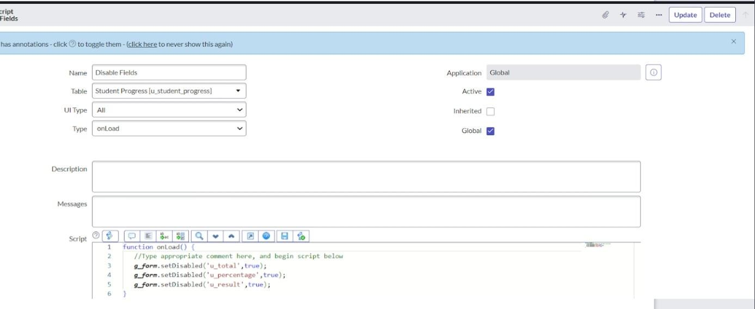

1. **Creating“TotalUpdate”ClientScriptsfor Student progress Table**

Step1-filltheDetailsas given.

Step2-WritetheCodeasbelow,EnableIsolatescriptand Save.

functiononChange(control,oldValue,newValue,isLoading, isTemplate) {

if(isLoading||newValue===''){ return;

}

//Type appropriate comment here, and begin script below if (newValue)

{

var a = parseInt(g_form.getValue('u_telugu')); var b = parseInt(g_form.getValue('u_hindi')); var c = parseInt(g_form.getValue('u_english')); var d = parseInt(g_form.getValue('u_maths')); vare=parseInt(g_form.getValue('u_science')); var f = parseInt(g_form.getValue('u_social')); var Total = parseInt(a+b+c+d+e+f); g_form.setValue('u_total', Total); }

}

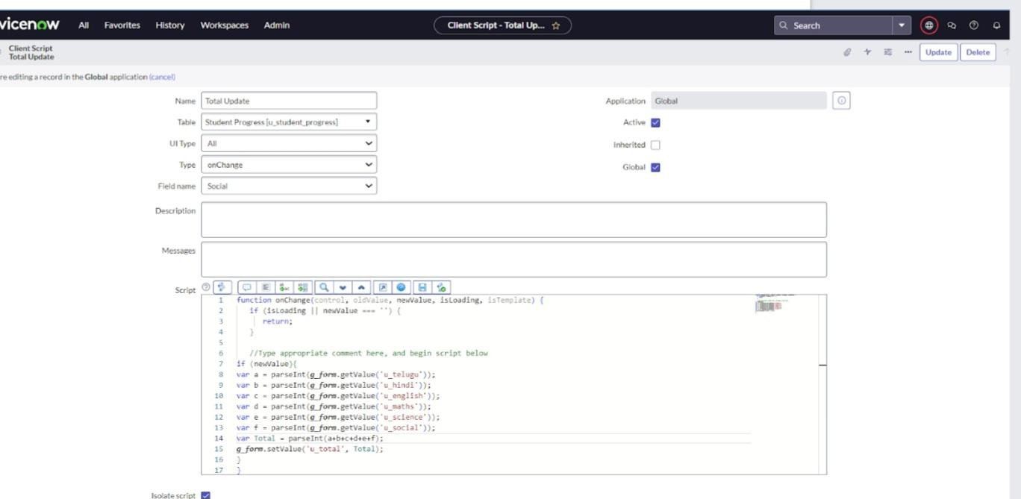

1. **Creating“Result”ClientScriptsforStudent progress Table**

Step1-FilltheDetailsasgiven.

Step2-WritetheCodeasbelow,EnableIsolatescript and Save

functiononChange(control,oldValue,newValue, isLoading, isTemplate) {

if(isLoading||newValue===''){ return;

**}**

//Type appropriate comment here, and begin script below if(newValue) {

var a = parseInt(g_form.getValue('u_percentage')); // Convert the value to an integer for comparison

if(a >= 0 && a <= 59){ g_form.setValue('u_result','Fail');

} else if(a >= 60 && a <= 100) { g_form.setValue('u_result','Pass');

}else{

// Handle the case if a is out of range (optional) g_form.addErrorMessage('Percentage should be

between0and100.');

g_form.clearValue('u_result');}

}

}

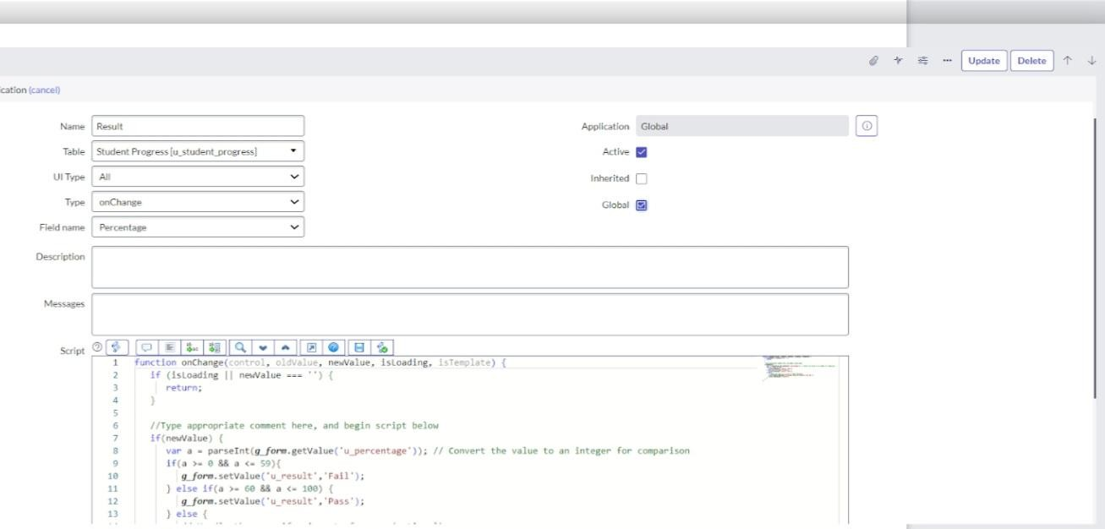

1. **Creating“Percentage”ClientScriptsfor Student progress Table**

Step1-FilltheDetailsasgiven.

Step2-WritetheCodeasbelow,EnableIsolatescript and Save

functiononChange(control,oldValue,newValue, isLoading, isTemplate) {

if(isLoading||newValue===''){ return;

**}**

**//Typeappropriatecommenthere,andbegin script below**

**varTotal=g_form.getValue('u_total'); var Percentage = (Total/600)*100;**

**g_form.setValue('u_percentage',Percentage+'**

**%');**

**}**

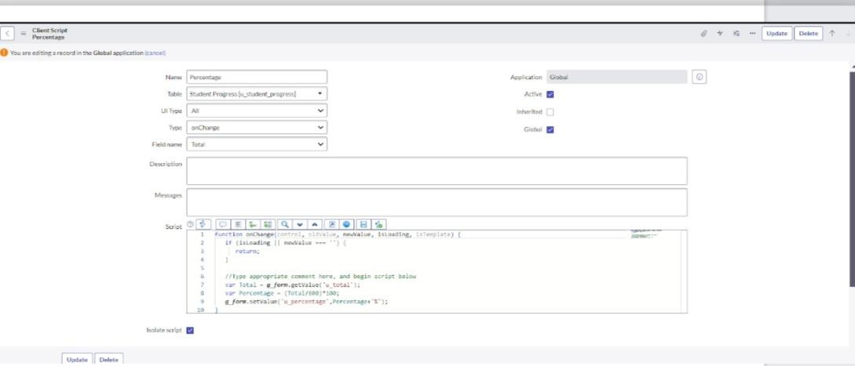

# CONCLUSION

**EducationOrganizationhassuccessfullyharnessedthepowerofServiceNow to transform our operations, enhance student experiences, and drive efficiency. By leveraging this innovative platform, we've created a more collaborative, productive, and student-centric environment. We're excited to continue exploring new ways to leverage ServiceNow to drive excellence in education."**

# CONCLUSION

Education Organization has successfully harnessed the power of ServiceNow to transform our operations, enhance student experiences, and drive efficiency. By leveragingthisinnovativeplatform,we'vecreatedamore collaborative, productive, and student-centric environment. We're excited to continue exploring new ways to leverage ServiceNow to drive excellence in education.”

**THANKYOU**